#13 |  |  | Alessandra Colón |  |  | 3B/Util | 2023
 | 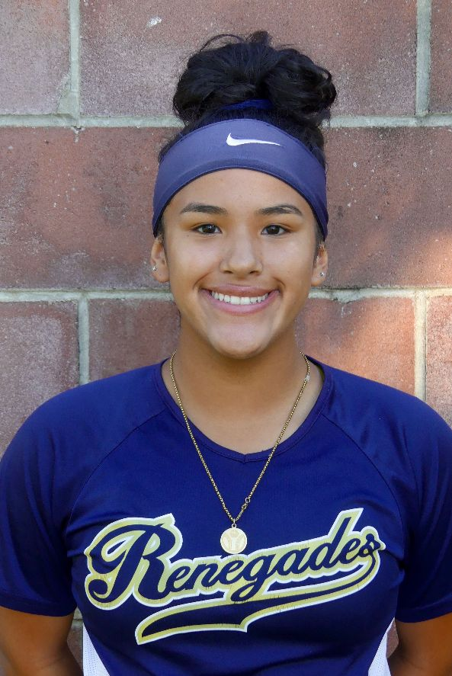  16/18U Torres |  |  |  |  | PERSONAL INFORMATION:  Bats/Throws: Right/Right  Birthdate: 09/18/2005  Height: 5’3” Weight: 155 Age: 15  Parents: Jay and Iliana Colón  Email: acnoloc13@gmail.com  Address: North Brunswick, NJ  Phone: 908-705-2990
 |  | COACHES CONTACT INFORMATION  Club Team:  Renegades Fastpitch  Head Coach: Juan Torres  Email: renegadesfp@gmail.com  Mobile: 484-542-5651  Recruiter: Patti Adorna  Email: padorna@turn2sportsconsulting.com  Mobile: 732-455-3972  High School:  North Brunswick Township High School  North Brunswick, NJ  Head Coach: Mary Rossi  Email: mrossi@nbtschools.org  Hitting Coach:  Ozzie Fernando  ozziebaseball@gmail.com  973-294-0657 |  |  | SOFTBALL ACHIEVEMENTS  High School  North Brunswick Township High School  Varsity (2019-2020)  Club Team History  Current:  Renegades Fastpitch 16/18U Torres  Past:  2018 - 2019 Team Long Island 05  2017 - 2018 Renegades Torres  2016 - 2017 PA Outlaws Torres  Social Media/Game Highlights  Athletes Go Live Team Feed:  Renegades Fastpitch 16/18 Torres  - 2018 USSSA Word Series Champions  - Varsity Freshman Year
 |  | ACADEMIC INFORMATION  Major of Interest:  Physical Therapy / Criminology  GPA:  3.77 |  |  | OTHER ACHIEVEMENTS & ACTIVITIES  - JV – Winter Track

