#8 |  | Alyssa Santiago |  |  |  | MI,OF,P | 2022
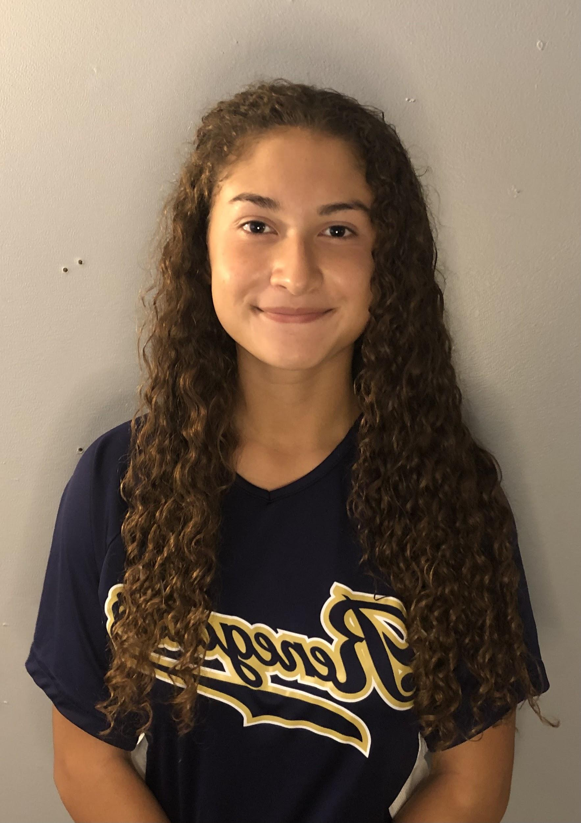  Renegades 18U Rodriguez |  |  |  |  | PERSONAL INFORMATION:  Bats/Throws: R/R  Birthdate: 08/03/2004  Height: 5’2 Weight: 121 Age: 16  Parents: Johanna and Gilberto Santiago  Email: alyssasantiago2022@gmail.com  Address: 66 Woodview Drive  Old Bridge, NJ, 08857  Phone: 732-841-3828
 | COACHES CONTACT INFORMATION  Club Team:  Renegades Fastpitch 18u Rodriguez  Head Coach: Christina Rodriguez Email:renegadesfpac@gmail.com  Mobile: 908-910-0564  President/Recruiter: Juan Torres  Email: renegadesfp@gmail.com  Mobile: 484-542-5651  High School:  Old Bridge High School  Old Bridge, NJ  Head Coach: Angela D’Amico  Email: adamico117@gmail.com |  |  | SOFTBALL ACHIEVEMENTS  High School/Middle School  - Old Bridge High School/ Jonas Salk Middle School  - Old Bridge Varsity Softball (2018- 2022)  Club Team History  - Current:  - Renegades 18u Rodriguez  - Past:  - 2020-2021 Renegades 18U Rodriguez  - 2019-2020 NJ Ruthless 16U Borrelli  - 2018-2019 NJ Ruthless 14U Gabriel  - 2017-2018 Marlboro Mayhem 14U Capone  - 2016-2017 Central Jersey Force 12U
 | ACADEMIC INFORMATION  Major of Interest: Undecided  GPA:  - 4.153 weighted |  |  | OTHER ACHIEVEMENTS & ACTIVITIES  - Winter Track

