#30 |  |  | Brittney Baber |  |  | 1B/OF | 2023
 | 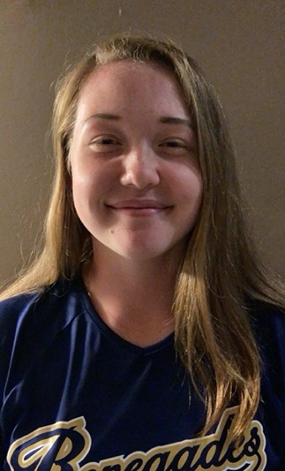  18U Rodriguez |  |  |  |  | PERSONAL INFORMATION:  Bats/Throws: R/R  Birthdate: 03/30/05  Height: 5’9 Weight: 190 Age: 15  Parents: Bryan Baber and Victoria Baber  Email: brittneybaber2023@gmail.com  Address: 44 Wilcox Ave  South River, NJ 08882  Phone: 732-427-3841
 |  | COACHES CONTACT INFORMATION  Club Team:  Renegades Fastpitch 18u Rodriguez  Head Coach: Christina Rodriguez  Email: Coachrodriguez1@gmail.com  Mobile: 908-910-0564  President: Juan Torres  Email: renegadesfp@gmail.com  Mobile: 484-542-5651  Recruiter: Patti Adorna  Email: padorna@turn2sportsconsulting.com  Mobile: 732-455-3972  High School:  South River High School  South River, NJ  Head Coach: Matthew Fadden  Email: mfadden@srivernj.org  Hitting Coach:  Christina Rodriguez  Email: Coachrodriguez1@gmail.com  Mobile: 908-910-0564 |  |  | SOFTBALL ACHIEVEMENTS  Club Team History  - Current:  - Renegades 18u Rodriguez  - Past:  - 2019-2020 Ruthless 16u Borelli  - 2018 -2019 Central Jersey Flames  - 2017-2018 Jersey Shore Huskies  Social Media  Instagram: @brittneybaber2023  Twitter: @baber_brittney  - USSSA Homerun Club  - Renegades ‘Over the Fence’ Club
 |  | ACADEMIC INFORMATION  Major of Interest:  Education/Graphic Design  GPA:  - 3.9 |  |  | OTHER ACHIEVEMENTS & ACTIVITIES  - High School Volleyball  - Middle School Basketball  - Junior Honor Society  - Student ambassador at St. Bartholomew School  - Middle school Mentoring Program  - Middle School Yearbook Committee  - STEM club  - Art Award (Grade 8)

