#2 |  |  | Dana Williams |  |  | 2B/OF | 2022
 | 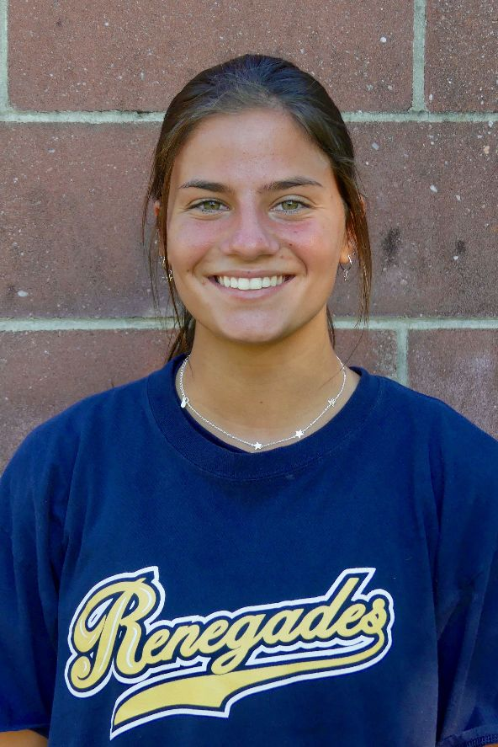  16/18U Torres |  |  |  |  | PERSONAL INFORMATION:  Bats/Throws: Right/Right  Birthdate: 01/02/2004  Height: 5’5 Weight: 125 Age: 16  Parents: Chrissy and Danny Williams  Email: danaw111@icloud.com  Address: 300 Round Hill Dr  Freehold, NJ 07728  Phone: 732-427-0062
 |  | COACHES CONTACT INFORMATION  Club Team:  Renegades Fastpitch  Head Coach: Juan Torres  Email: renegadesfp@gmail.com  Mobile: 484-542-5651  Recruiter: Patti Adorna  Email: padorna@turn2sportsconsulting.com  Mobile: 732-455-3972  High School:  Freehold Township High School  Freehold, NJ  Head Coach: Michael Stoia  Email: mstoia@frhsd.com |  |  | SOFTBALL ACHIEVEMENTS  High School  Freehold Township High School  Varsity (2020)  Club Team History  Current:  Renegades Fastpitch 16/18u Torres  Past:  2017-2020 Batbusters  2014-2016 Nightmare fastpitch  Social Media/Game Highlights  Athletes Go Live Team Feed:  Renegades Fastpitch 16/18 Torres
 |  | ACADEMIC INFORMATION  Major of Interest:  Undecided  GPA:  3.6 |  |  | OTHER ACHIEVEMENTS & ACTIVITIES

