#2 Giana Fredericks SS/OF 2022
 | 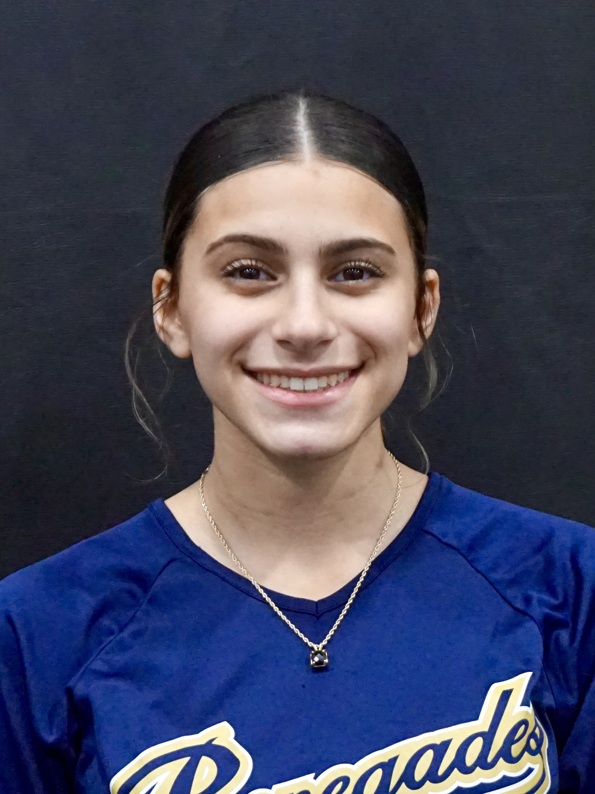  16u |  |  |  | PERSONAL INFORMATION:  Bats/Throws: R/R  Birthdate: 08/16/2004  Height: 5’2 Weight: 105 Age: 14  Parents: Stu & Melissa Fredericks  Email: GiaF2004@gmail.com  Address: 504 S. Greenwood Ave  Easton, PA 18045  Phone: 484-542-4883
 |  | COACHES CONTACT INFORMATION  Travel Team:  Renegades Fastpitch 14U Clarke  Asbury, NJ  Head Coach: John Clarke  Email: renegadesfpclarke@gmail.com  201-321-6565  President/Recruiter: Juan Torres  Email: renegadesfp@gmail.com  484-542-5651  High School:  Easton Area High School  18045, PA  Head Coach: Ed McIntyre  Email: mcintyree@eastonsd.org  Hitting Coach:  Steve Nikorak  contact@zonedinc.com  732-537-1770 |  | SOFTBALL ACHIEVEMENTS  High School:  Easton Area High School, Easton, PA 18045  Travel Ball History  - Current 14U Renegades Fastpitch  - Coach John Clarke  - 2018 PA Outlaws 18U PREMIER  - Coach Jeremy Stanilious  - 2017-2018 PA Outlawas 18U GOLD  - Coach Jeremy Stanilious  - 2017 PA Outlaws 18U ELITE  - Coach Jeremy Stanilious  - 2016-2017 PA Outlaws 12U ELITE  - Coach Eric Beltz & Don Langdon  - 2015-2016 PA Outlaws 12U ELITE  - Coach Jack Roman
 |  | ACADEMIC INFORMATION  Major of Interest: Dental (Orthodontist)  GPA: |  | OTHER ACHIEVEMENTS & ACTIVITIES  - National Junior Honors Society (2016 & 2018)

