#18 |  |  | Jaelynn Barrios |  |  | 1B/OF | 2021
 | 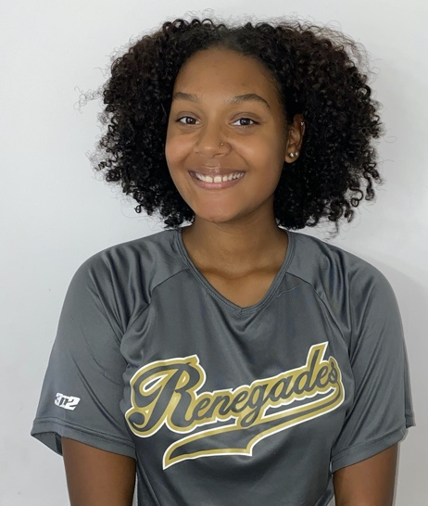  18U Rodriguez |  |  |  |  | PERSONAL INFORMATION:  Bats/Throws: R/R  Birthdate: 01/30/2003  Height: 5’7 Weight: 170 Age: 17  Parents: Manny Barrios/ Shaela MontesDeOca  Email: jaelynnbarrios2021rfp@gmail.com  Address: 296 Avenue B  Bayonne, NJ 07002  Phone: 551-208-2408
 |  | COACHES CONTACT INFORMATION  Club Team:  Renegades Fastpitch 18U Rodriguez  Head Coach: Christina Rodriguez  Email:coachrodriguez1@gmail.com  Mobile: 908-910-0564  President/Recruiter: Juan Torres  Email: renegadesfp@gmail.com  Mobile: 484-542-5651  High School:  Bayonne High School  Bayonne, New Jersey  Head Coach: Samantha Maggio  Email: samaggio@bboed.org  Hitting Coach:  Sean Mchale  renegadesfpvp@gmail.com  973-953-5565 |  |  | SOFTBALL ACHIEVEMENTS  - Jennie Finch Empowerment Award Winner 2019  - 1st Team All County 1st Basemen 2019  - Select Player of MLB Breakthrough Series 2019  - Select Play of MLB Elite Development Invitational 2019  - HS Player of the Week 2019  - Senior Spotlight of New Jersey 2020  High School/Middle School  Bayonne High/Woodrow Wilson School  - Varsity (2018-2021)  Club Team History  - Current:  - Renegades 18U Rodriguez  - Past:  - 2013-2016 Bayonne Fury 12U, 16U  - 2017-2019 NJ Chaos 16U, 18U  - 2019-present Renegades Fastpitch 16U, 18U
 |  | ACADEMIC INFORMATION  Major of Interest:  - Health Science  GPA:  - 4.0weighted |  |  | OTHER ACHIEVEMENTS & ACTIVITIES  - National Junior Honor Society  - Winner of the Panasonic Student Eco Citizenship Project  - 1st and 2nd Honor roll student through all academic years

