#5 |  |  | Kori Gargiulo |  |  | 1B/2B/OF | 2022
 | 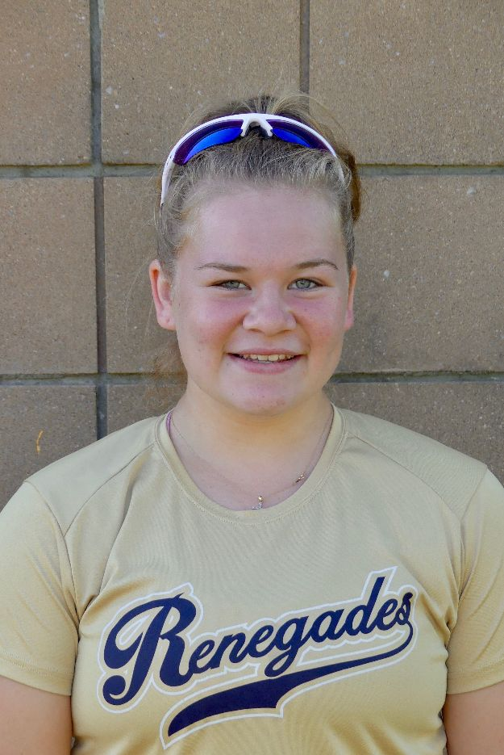  16/18U Torres |  |  |  |  | PERSONAL INFORMATION:  Bats/Throws: Right/Right  Birthdate: 08/25/2004  Height: 5’3 Weight: 169 Age: 16  Parents: Kim and Glen Gargiulo  Email: Kgargiulo05@gmail.com  Address: 540 Line Road  Hazlet, NJ 07730  Phone: 732-757-5675
 |  | COACHES CONTACT INFORMATION  Club Team:  Renegades Fastpitch  Head Coach: Juan Torres  Email: renegadesfp@gmail.com  Mobile: 484-542-5651  Recruiter: Patti Adorna  Email: padorna@turn2sportsconsulting.com  Mobile: 732-455-3972  High School:  Raritan High School  Hazlet, New Jersey  Head Coach: Mark Rosner  Email: Mrosner@gmail.com  Hitting Coach:  Katie Baron  KateBaron14@gmail.com  973-294-0657 |  |  | SOFTBALL ACHIEVEMENTS  High School  Raritan High School  Middle School 2017-2018  Varsity (2019-2022)  Club Team History  Current:  Renegades Fastpitch 16/18u Torres  Past:  2017-2019 NJ Rage  2017 Hazlet Hawks  Social Media/Game Highlights  Athletes Go Live Team Feed:  Renegades Fastpitch 16/18 Torres  - 2018 Clutch Hitter Award  - 2019 Rocket Pride Award
 |  | ACADEMIC INFORMATION  Major of Interest:  Health Science  GPA:  98.550 weighted  94.734 unweighted |  |  | OTHER ACHIEVEMENTS & ACTIVITIES  - FR/JV/Varsity Volleyball  - Resilience Award for Freshmen Volleyball  - High Honor Roll MP 1- MP 4

