#00 |  |  | Kristal Torres |  |  |  | C/OF | 2023
 | 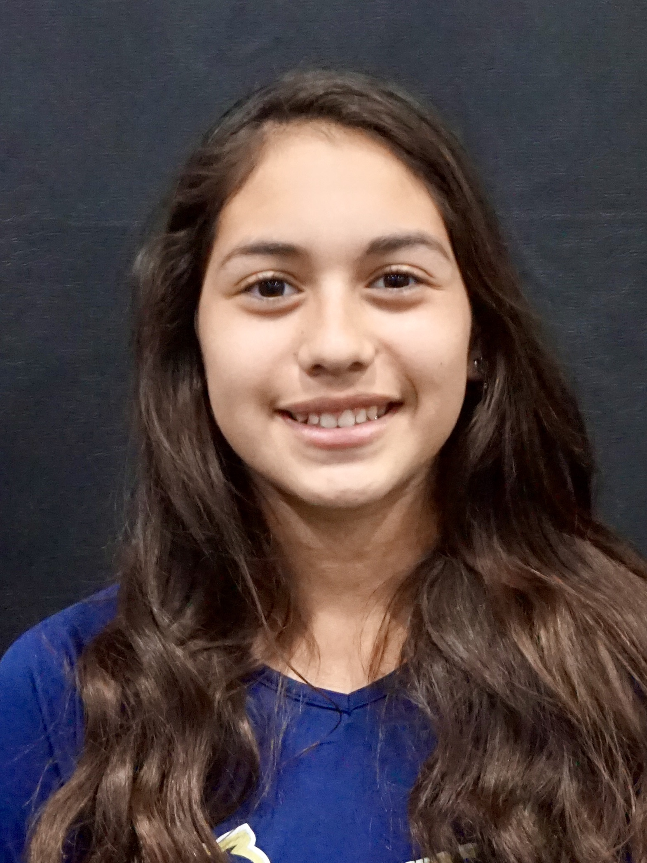  16u/18u  Torres |  |  |  |  | PERSONAL INFORMATION:  Bats/Throws: L/R  Birthdate: 6/17/2005  Height: 5’3 Weight: 132 Age: 15  Parents: Juan and Milvia  Email: 00kristaltorres@gmail.com  Address: Easton, PA  Phone: 484-541-6268
 |  | COACHES CONTACT INFORMATION  Club Team:  Renegades Fastpitch 16u/18u Torres  Head Coach: Juan Torres  Email: renegadesfp@gmail.com  Mobile: 484-542-5651  President/Recruiter: Patti Adorna  Email: Padorna@turn2sportsconsulting.com  Mobile: 732-455-3972  High School:  BETHLEHEM CATHOLIC High School  Bethlehem, PA  Head Coach: Rich Mazza  Hitting Coach:  Hannah Edwards  973-294-0657 |  |  | SOFTBALL ACHIEVEMENTS  - 2018 USSSA WORLD SERIES 12U NATIONAL CHAMPIONS- Renegades 12U Gold  - 2018 USSSA World Series Championship Defensive Player Of The Game  - Numerous Game MVP  - Jr High Team Captain- 2 Years  High School/Middle School  Bethlehem Catholic  - Varsity (2020 Freshman)  Club Team History  - Current:  - Renegades Fastpitch 16u/18u Torres  - Past:  - 2018-2019 Renegades 14U Torres  - 2017-2018 Renegades 12U Gold  - 2016-2017 Outlaws Fastpitch 12U  - 2015-2016 Outlaws Fastpitch 10U  - 2014-2015 Outlaws Fastpitch 10U
 |  | ACADEMIC INFORMATION  Major of Interest:  - Psychology  GPA:  - 3.8 |  |  | OTHER ACHIEVEMENTS & ACTIVITIES  - Bethlehem Catholic Photography Club  - YES Select JR High Student  - National Honor Society Member  - January 2020 Student Freshman Of The Month

