#11 |  |  | Lila Williams |  |  | SS | 2022
 | 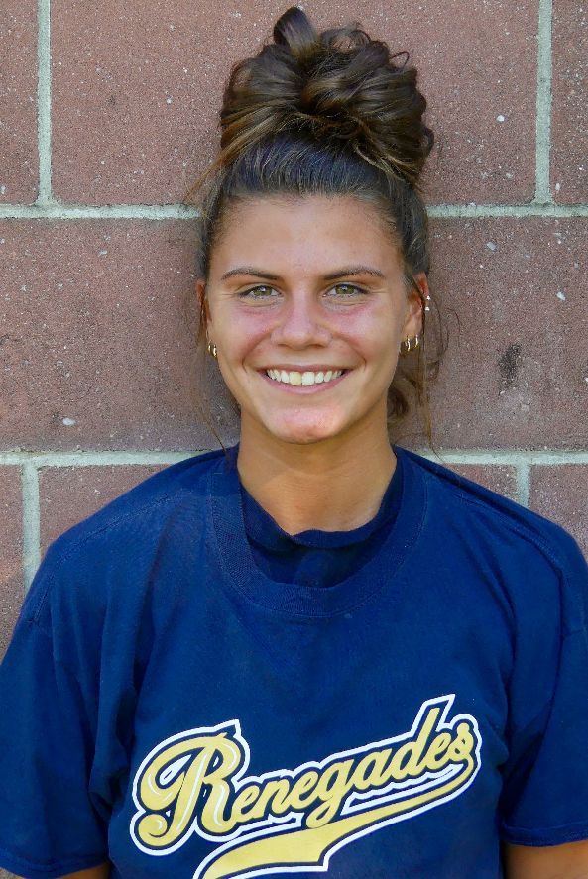  16/18U Torres |  |  |  |  | PERSONAL INFORMATION:  Bats/Throws: Right/Right  Birthdate: 01/02/2004  Height: 5’5 Weight: 135 Age: 16  Parents: Chrissy and Danny Williams  Email: lila1208@icloud.com  Address: 300 Round Hill Dr.  Freehold, NJ 07728  Phone: 732 427-0063
 |  | COACHES CONTACT INFORMATION  Club Team:  Renegades Fastpitch  Head Coach: Juan Torres  Email: renegadesfp@gmail.com  Mobile: 484-542-5651  Recruiter: Patti Adorna  Email: padorna@turn2sportsconsulting.com  Mobile: 732-455-3972  High School:  Freehold Township High School  Freehold, NJ  Head Coach: Michael Stoia  Email: mstoia@frhsd.com |  |  | SOFTBALL ACHIEVEMENTS  High School  Freehold Township High School  Varsity (2019-Currently)  Club Team History  Current:  Renegades Fastpitch 16/18u Torres  Past:  2018 - 2020 NJ Batbusters Pembleton  2016 – 2018 NJ Nightmare  Social Media/Game Highlights  Athletes Go Live Team Feed:  Renegades Fastpitch 16/18 Torres  - Softball Captain (2018)  - All Star MVP (2018)
 |  | ACADEMIC INFORMATION  Major of Interest:  Undecided  GPA:  4.6 weighted  3.6 unweighted |  |  | OTHER ACHIEVEMENTS & ACTIVITIES  - Soccer Captain (2017)  - High Honor Roll (2015-2020)

