#25 |  |  | Madison Boen |  |  | C/OF | 2022
 | 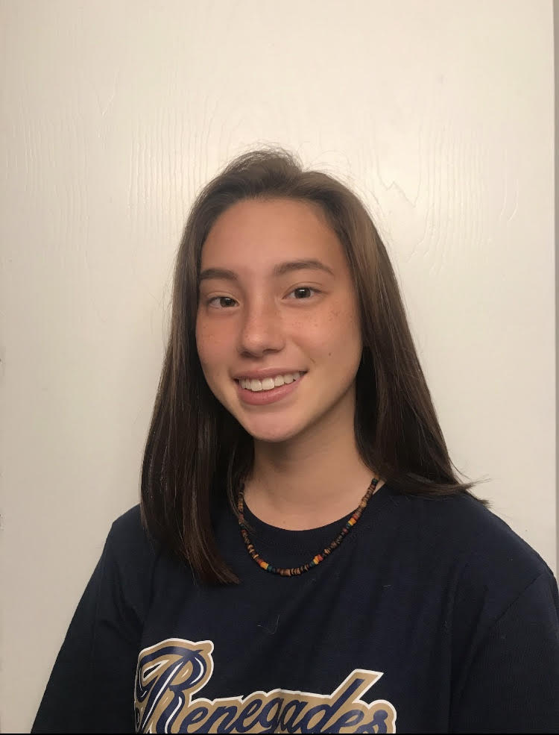  18u Rodriguez |  |  |  |  | PERSONAL INFORMATION:  Bats/Throws: R/R  Birthdate: 1/24/2004  Height: 5’3 Weight: 115lbs Age: 16  Parents: Michele Mercado and Chian Boen  Email: MadisonBoen2022@gmail.com  Address: 8 Mason Avenue  East Brunswick, NJ 08816  Phone: 732-484-3867
 |  | COACHES CONTACT INFORMATION  Club Team:  Renegades Fastpitch 18u Rodriguez  Head Coach: Christina Rodriguez  Email: Coachrodriguez1@gmail.com  Mobile: 908-910-0564  President/Recruiter: Juan Torres  Email: renegadesfp@gmail.com  Mobile: 484-542-5651  High School:  East Brunswick High School  East Brunswick, NJ  Head Coach: Kevin Brady  Email: Kbrady@ebnet.org |  |  | SOFTBALL ACHIEVEMENTS  - Varsity player of the game: East Brunswick vs. Monroe Township 2019  - Varsity player of the game: East Brunswick vs. Bishop Ahr 2019  - Starting catcher Freshmen year for varsity  High School/Middle School  East Brunswick High School/Churchill Junior High School  - Varsity softball (2018-2020)  Club Team History  - Current:  - Renegades 16/18U Contreras  - Past:  - 2018-2020 NJ Ruthless Borelli  - 2017-2018 Marlboro Mayhem  - 2016-2017 East Brunswick Zenyattas
 |  | ACADEMIC INFORMATION  Major of Interest:  - Criminal Justice  GPA:  - 3.74 Weighted  - 3.65 unweighted |  |  | OTHER ACHIEVEMENTS & ACTIVITIES  - Varsity Winter track (2018-2020)  - Athlete of the month for Winter track (2019)  - Asian Club(2020)

