#1 |  |  | Mallory Allen |  |  | 2B/RHP | 2023
 | 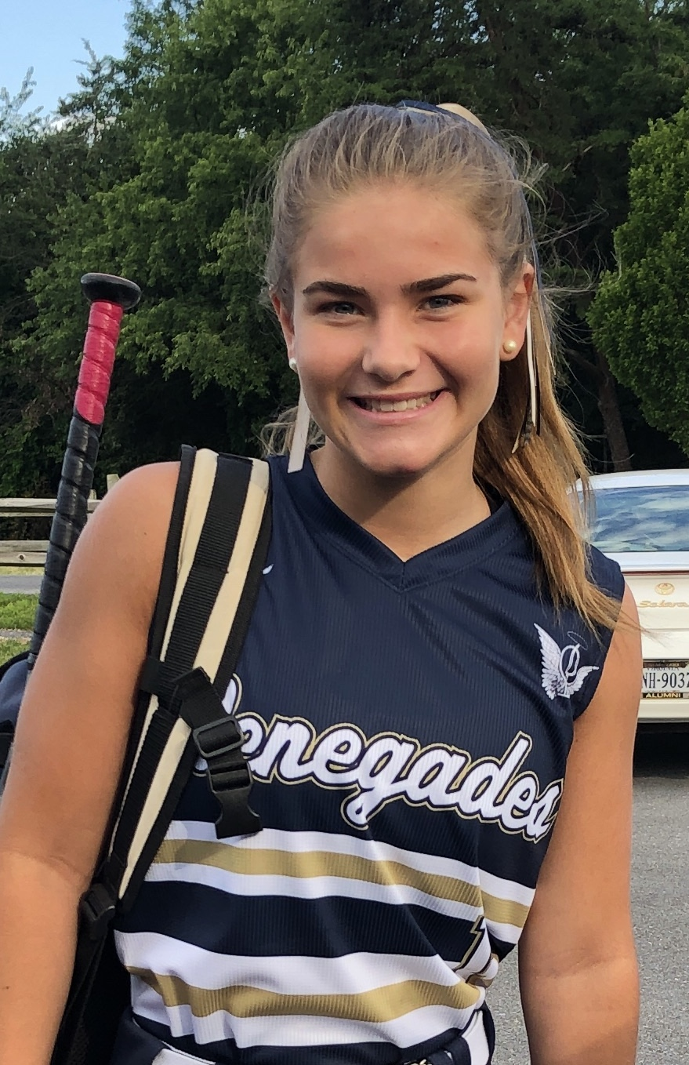  16/18U Torres |  |  |  |  | PERSONAL INFORMATION:  Bats/Throws: Right/Right  Birthdate: 4/13/2005  Height: 5’3” Weight: 122 Age: 15  Parents: Christine Allen and Lucas Allen  Email: 2005mal2005@gmail.com  Address: 40 Cobblewood Road  Blairstown, NJ 07825  Phone: 908-645-2796
 |  | COACHES CONTACT INFORMATION  Club Team:  Renegades Fastpitch  Head Coach: Juan Torres  Email: renegadesfp@gmail.com  Mobile: 484-542-5651  Recruiter: Patti Adorna  Email: padorna@turn2sportsconsulting.com  Mobile: 732-455-3972  High School:  Blair Academy  Blairstown, NJ  Head Coach: Carolyn Conforti-Browse  Email: confoc@blair.edu  Hitting and Pitching Coach:  Lexi Davis |  |  | SOFTBALL ACHIEVEMENTS  High School  Blair Academy  Varsity 2020 - present  Club Team History  Current:  Renegades Fastpitch 16/18u Torres  Past:  2015-2017 PA Outlaws  2017-Current Renegades FP  Social Media/Game Highlights  Athletes Go Live Team Feed:  Renegades Fastpitch 16/18 Torres  - 12u USSSA Space Coast World Series Champions
 |  | ACADEMIC INFORMATION  Major of Interest:  Exercise Science  GPA:  5.25 out of 6.0 |  |  | OTHER ACHIEVEMENTS & ACTIVITIES  - Varsity Soccer  - Varsity winter Track and Field  - Freshman of the Year (2020)  - Best All Around Girl (2019)  - Presidential Award (2017)  - Valedictorian (2017)

