#18 |  |  | Olivia Smith |  |  | 1B/LHP | 2023
 | 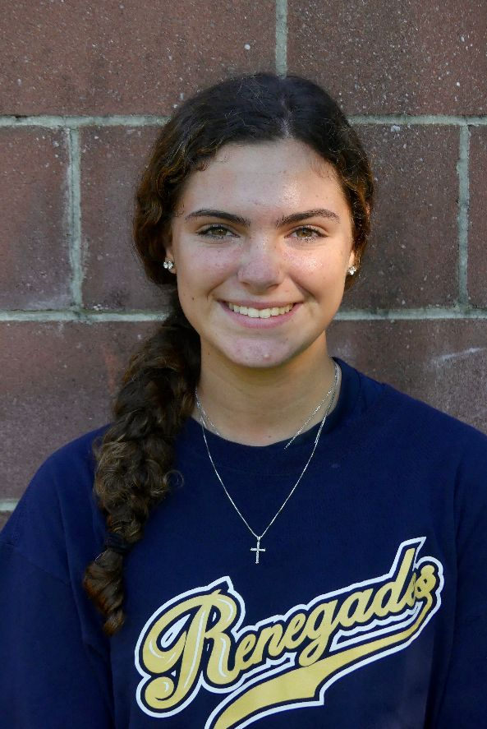  16/18U Torres |  |  |  |  | PERSONAL INFORMATION:  Bats/Throws: Left/Left  Birthdate: 02/23/2005  Height: 5’5 Weight: 115 Age: 15  Parents: Todd and Dawn Smith  Email: 18LivSmith@gmail.com  Address: 8 Lani Court  Freehold, NJ 07728  Phone: 732-598-0452
 |  | COACHES CONTACT INFORMATION  Club Team:  Renegades Fastpitch  Head Coach: Juan Torres  Email: renegadesfp@gmail.com  Mobile: 484-542-5651  Recruiter: Patti Adorna  Email: padorna@turn2sportsconsulting.com  Mobile: 732-455-3972  High School:  Freehold Twp High School  Freehold, NJ 07728  Head Coach: Mike Stoia  Email: MStoia@frhsd.com  Slapping/Hitting Coach:  India Chiles  slappernationsoftball@gmail.com  Sydney Turchin  609-462-2743  Pitching Coach:  Jacelyn Peterson  732-470-3508 |  |  | SOFTBALL ACHIEVEMENTS  Barkalow Middle School  Undefeated District Champions  Team captain  Club Team History  Current:  Renegades Fastpitch 16/18u Torres  Past:  2019-2020 Renegades Barrios  2016-2018 RKE JAXX  2015-2016 RKE CJ Mayhem  Social Media/Game Highlights  Athletes Go Live Team Feed:  Renegades Fastpitch 16/18 Torres  Recruiting Website and Skills Video:  https://www.t2sc.me/olivias  - Daughters of The American Revolutionary War Award for Leadership, Sportsmanship and Community Service
 |  | ACADEMIC INFORMATION  Major of Interest:  Physician’s Assistant, Education  GPA:  3.9 weighted |  |  | OTHER ACHIEVEMENTS & ACTIVITIES  - Field Hockey -Center Mid  - Basketball -Point Guard

