#15 |  |  | Savanna McHale |  |  | RHP/3B/1B | 2024
 | 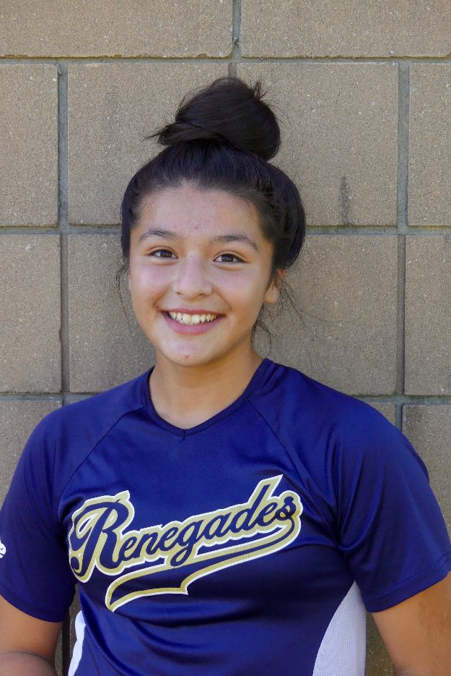  16/18U Torres |  |  |  |  | PERSONAL INFORMATION:  Bats/Throws: Right/Right  Birthdate: 12/29/2005  Height: 5’6 Weight: 150 Age: 14  Parents: Shawn McHale  Email: savannamack15@gmail.com  Address: 10 Poplar Street  Jersey City, NJ 07307  Phone: 201-268-8563
 |  | COACHES CONTACT INFORMATION  Club Team:  Renegades Fastpitch  Head Coach: Juan Torres  Email: renegadesfp@gmail.com  Mobile: 484-542-5651  Recruiter: Patti Adorna  Email: padorna@turn2sportsconsulting.com  Mobile: 732-455-3972  High School:  Weehawken High School  Weehawken, NJ  Head Coach: Raquel Roder  Email: Rroder@weehawken.k12.nj.us  Hitting Coach:  Raf Hernández  646-270-0201  Pitching Coach:  Alexia Russo  201-468-7290 |  |  | SOFTBALL ACHIEVEMENTS  High School  Weehawken High School  Varsity (TBD)  Club Team History  Current:  Renegades Fastpitch 16/18u Torres  Past:  2018-2020 Renegades Fastpitch 14u Torres  2017-2018 Renegades Fastpitch 12u Torres  2016-2017 PA Outlaws12u Torres  2015-2016 PA Outlaws 10u Torres  Social Media/Game Highlights  Athletes Go Live Team Feed:  Renegades Fastpitch 16/18 Torres  - 2017 USSSA PA State Finalist  - 2018 USSSA World Series Champion  - 2019 extra Innings pitcher ranked #81 in 2024 class
 |  | ACADEMIC INFORMATION  Major of Interest:  English  GPA:  N/A |  |  | OTHER ACHIEVEMENTS & ACTIVITIES  - National Junior Honor Society Member  - Captain of Middle School Volleyball Team  - 2020 Volleyball citywide champion  - 2020 Volleyball MVP

