#44 |  |  | Sara McNelly |  |  | SS/OF | 2023
 | 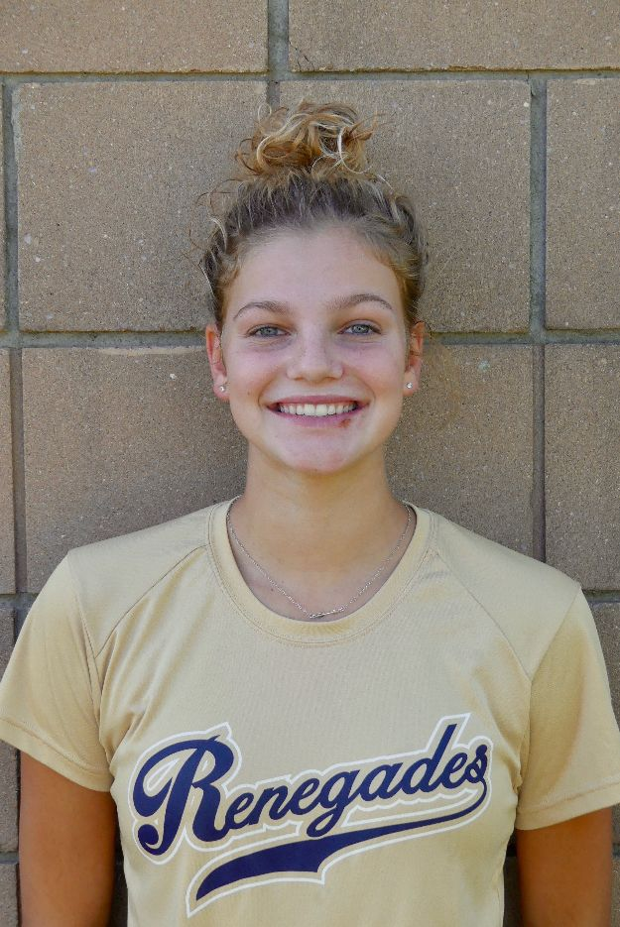  16/18U Torres |  |  |  |  | PERSONAL INFORMATION:  Bats/Throws: Right/Right  Birthdate: 09/08/2005  Height: 5’7” Weight: 125 Age: 15  Parents: Lloyd and Aneca McNelly  Email: saramcnelly2023@gmail.com  Address: 154 South Madison Drive  South Plainfield, NJ 07080  Phone: 908-872-8108
 |  | COACHES CONTACT INFORMATION  Club Team:  Renegades Fastpitch  Head Coach: Juan Torres  Email: renegadesfp@gmail.com  Mobile: 484-542-5651  Recruiter: Patti Adorna  Email: padorna@turn2sportsconsulting.com  Mobile: 732-455-3972  High School:  South Plainfield High School  South Plainfield, NJ 07080  Head Coach: Donald Panzarella  Email: dpanzarella@spboe.org |  |  | SOFTBALL ACHIEVEMENTS  High School  South Plainfield High School  Varsity 2020 (Freshman)  Club Team History  Current:  Renegades Fastpitch 16/18u Torres  Past:  2018-2020 Renegades Fastpitch 14u Torres  2017-2018 NJ Batbusters 12u  Social Media/Game Highlights  Athletes Go Live Team Feed:  Renegades Fastpitch 16/18 Torres  - USSSA All Tournament Eastern PA/NJ 2018  - Selected for Under Armor Softball Factory  National Team 2020  - Renegades “Over the Fence” Club
 |  | ACADEMIC INFORMATION  Major of Interest:  Physical Therapy  GPA:  4.13 weighted/3.78 unweighted |  |  | OTHER ACHIEVEMENTS & ACTIVITIES  - Varsity Basketball Freshman year  Rookie of the Year  - Volunteer for South Plainfield Recreation  Buddy Ball program

